Course Code: AIPP
Assignment No: 13
Done by: 2503B05203 (M.Tech)
Name: B Subhash Chandra

SCHOOLOFCOMPUTER SCIENCE AND ARTIFICIAL INTELLIGENCE |  |  |  |  | DEPARTMENTOFCOMPUTER SCIENCE ENGINEERING
Program Name: M. Tech/MCA/MSC |  |  |  | Assignment Type: Lab |  |  | AcademicYear:2025-2026
Course Coordinator Name |  |  |  | Venkataramana Veeramsetty
Course Code |  |  | 24CS002PC215 | Course Title |  | AI Assisted Problem Solving Using Python
Year/Sem |  |  | II/I | Regulation |  | R24
Date and Day  of Assignment |  |  | Week5- Tuesday | Time(s)
Duration |  |  | 2 Hours | Applicable to  Batches
AssignmentNumber:13.3(Presentassignmentnumber)/24(Totalnumberofassignments)
 | Q.No. | Question |  |  |  |  |  | ExpectedTime  to complete
 | 1 | Lab 13 – Code Refactoring: Improving Legacy Code with AI Suggestions  Lab Objectives  - To introduce the concept of code refactoring and why it matters (readability, maintainability, performance).  - To practice using AI tools for identifying and suggesting improvements in legacy code.  - To evaluate the before vs. after versions for clarity, performance, and correctness.  - To reinforce responsible AI-assisted coding practices (avoiding over-reliance, validating outputs).  Learning Outcomes  After completing this lab, students will be able to:  - Use AI to analyze and refactor poorly written Python code.  - Improve code readability, efficiency, and error handling.  - Document AI-suggested improvements through comments and explanations.  - Apply refactoring strategies without changing functionality.  - Critically reflect on AI’s refactoring suggestions.  Task Description #1 – Remove Repetition  Task: Provide AI with the following redundant code and ask it to refactor  Python Code  def calculate_area(shape, x, y=0):  if shape == "rectangle":  return x * y  elif shape == "square":  return x * x  elif shape == "circle":  return 3.14 * x * x  Expected Output  - Refactored version with dictionary-based dispatch or separate functions.  - Cleaner and modular design.  Prompt:  - Refactor the calculate_area function using the best method to make it clean, modular, and easily extendable.  Code:  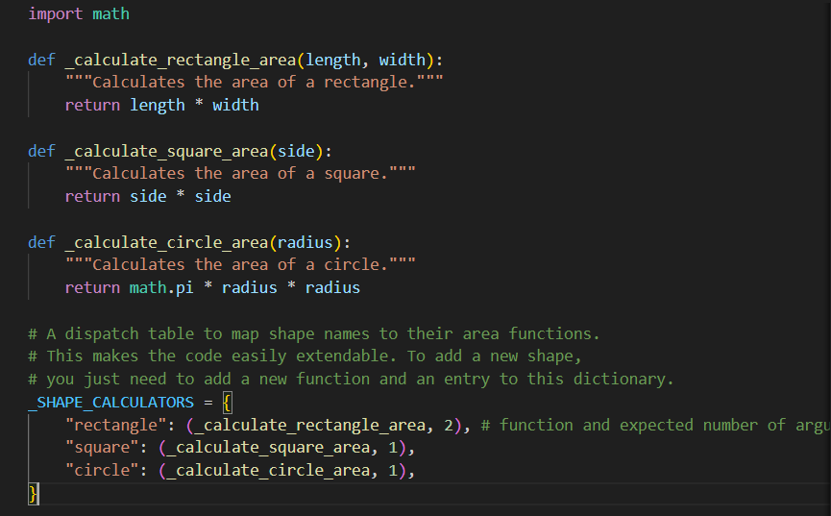  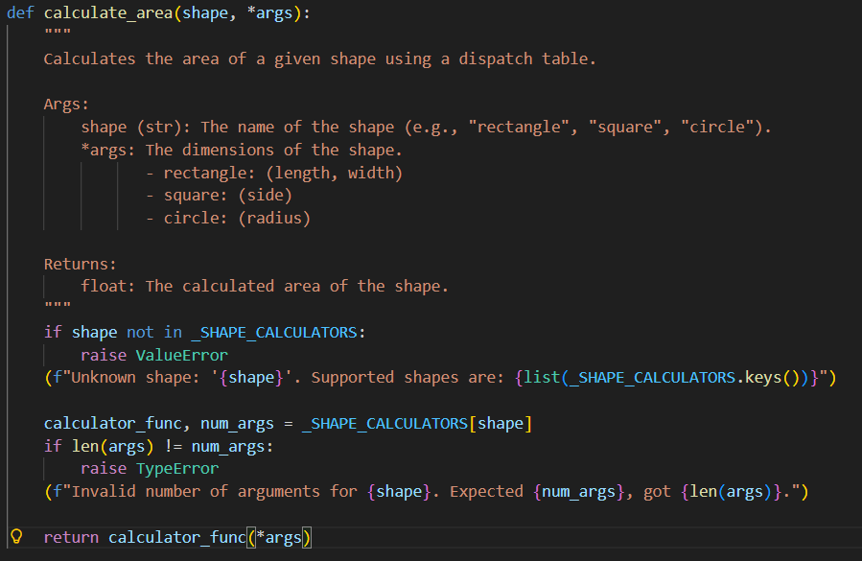  Code explanation:  - Defines separate functions to calculate the area of a rectangle, square, and circle.  - Uses a dispatch table (_SHAPE_CALCULATORS) mapping shape names to their area functions and expected argument count.  - calculate_area function takes a shape name and dimensions, looks up the correct function in the dispatch table, and calls it.  - Raises errors if the shape is unknown or the wrong number of arguments is provided.  - Modular design makes it easy to add new shapes by adding a function and an entry to the dispatch table.  Output:  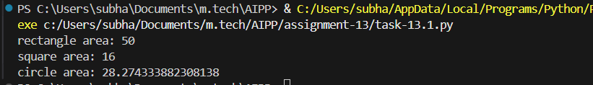  Conclusion:  - This AI refactored area calculation code demonstrates a clean, modular, and extensible design using a dispatch table.  - By separating functions for each shape and mapping them to shape names, it eliminates redundant if-elif statements and simplifies adding new shapes in the future.  - The use of *args allows flexible input for different shapes, while built-in checks ensure correct usage and prevent errors.  - Overall, the code is more readable, maintainable, and scalable thanks to this AI-assisted modular approach.  Task Description #2 – Error Handling in Legacy Code  Task: Legacy function without proper error handling  Python Code  def read_file(filename):  f = open(filename, "r")  data = f.read()  f.close()  return data  Expected Output:  AI refactors with with open() and try-except:  - Prompt:  Refactor read_file to use with open() and try-except for safe, robust file handling.  Code:  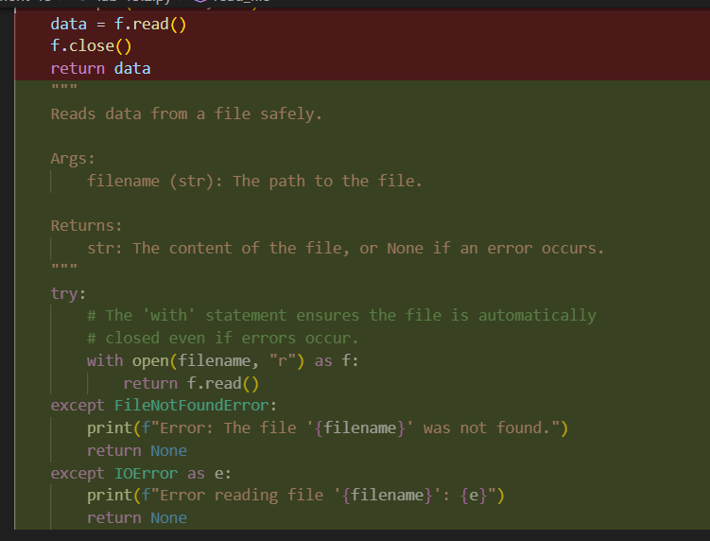  Explanation  - The AI refactored code uses a try-except block to handle errors such as the file not being found (FileNotFoundError) or other input/output errors (IOError).  - When an error occurs, it prints a clear error message and returns None instead of raising an exception.  - This approach improves resource management and provides user-friendly error handling.  Conclusion  This refactored function is more robust and safe, leveraging Python’s context manager (with) to manage file resources automatically. Proper error handling ensures the program can gracefully handle missing files or read errors without crashing, making the code reliable and user-friendly.  Task Description #3 – Complex Refactoring  Task: Provide this legacy class to AI for readability and modularity improvements:  Python Code  class Student:  def __init__(self, n, a, m1, m2, m3):  self.n = n  self.a = a  self.m1 = m1  self.m2 = m2  self.m3 = m3  def details(self):  print("Name:", self.n, "Age:", self.a)  def total(self):  return self.m1+self.m2+self.m3  Expected Output:  - AI improves naming (name, age, marks).  - Adds docstrings.  - Improves print readability.  - Possibly uses sum(self.marks) if marks stored in a list.  Prompt:  - Refactor this legacy Student class to improve readability and modularity. Focus on better variable naming, adding clear docstrings, enhancing output formatting, and optimizing the way marks are handled and totalled.  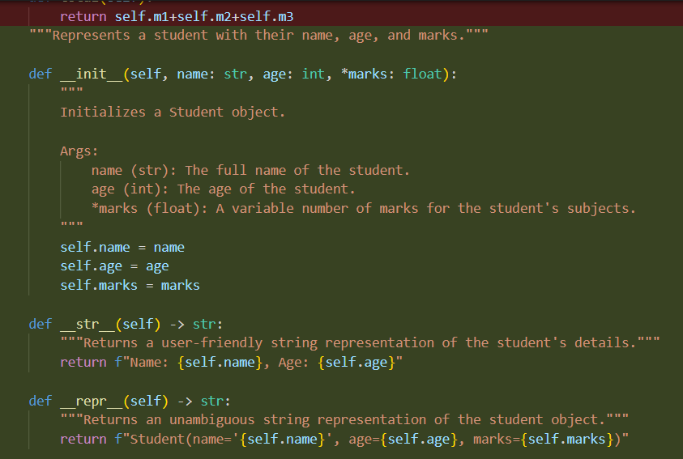  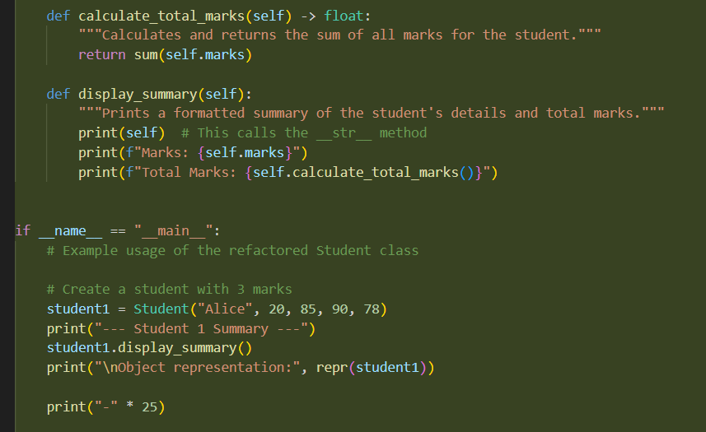  Code Explanation  - Defines a Student class with clear, descriptive variable names.  - Uses *marks to accept a flexible number of scores stored in a tuple.  - Includes docstrings for the class and its methods to improve clarity.  - Implements __str__ and __repr__ for user-friendly and detailed string representations.  - Provides methods to calculate total marks and display a formatted summary.  - Demonstrates flexibility by creating student instances with varying numbers of marks.  Output:  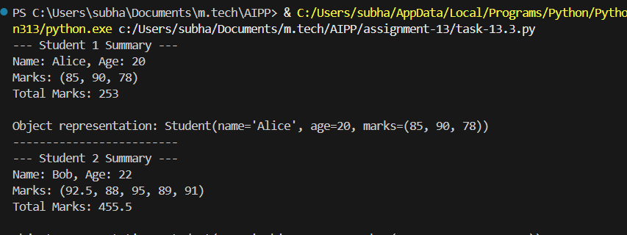  Conclusion  This refactored Student class improves readability, modularity, and usability. It leverages Python features like variable-length arguments, magic methods, and clear documentation to create clean, maintainable, and flexible code suitable for diverse use cases.  Task Description #4 – Inefficient Loop Refactoring  Task: Refactor this inefficient loop with AI help  Python Code  nums = [1,2,3,4,5,6,7,8,9,10]  squares = []  for i in nums:  squares.append(i * i)  Expected Output: AI suggested a list comprehension  Prompt:  - Refactor this loop to a more concise, efficient form  Code Explanation  - The code creates a list of numbers from 1 to 10.  - Uses a list comprehension to generate the squares of each number efficiently, replacing the explicit for-loop.  - Prints both the original list and the squared list in a readable format.  Code:  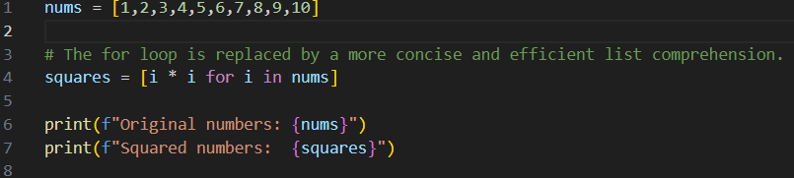  Output:  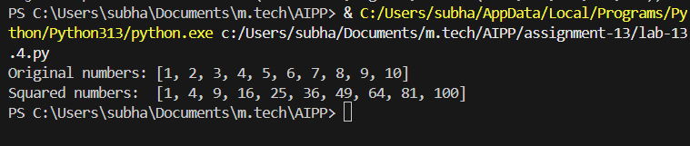  Conclusion  The refactored code is more concise, readable, and Pythonic. Using a list comprehension eliminates the need for manual appending, making the code cleaner and easier to maintain.  Lab Conclusion:  AI-assisted refactoring improves code readability, modularity, and efficiency by suggesting clearer naming, concise structures, and Pythonic constructs. It enhances robustness through error handling, input validation, and proper documentation, while optimizing common patterns like loops or dispatch tables for conciseness and scalability. Overall, AI support enables the creation of cleaner, maintainable, and easily extendable code across a variety of programming tasks. |  |  |  |  |  | Week5- Tuesday

